Eglin-Hurlburt Retired Fire Fighters
January 2001 Minutes

Twenty three Fire Chiefs and six of their wives enjoyed the fellowshipping and delicious breakfast buffet at the Golden Corral on a beautiful Saturday morning in Fort Walton Beach. The Corral will be new meeting site for all of 2001, 0800 to 0930, 2nd Saturday of each month. The "made-to-order Omelettes" was a big hit. The "Western Omelet" was a meal in it's self and almost to pretty to eat.

Fire Chief Richard Oblak jokingly chastised the "Group" they ought not make to many trips to the buffet...look what happen to Quincy's Family Steakhouse...they closed their doors after over 30 year in business.

It was really great to have so many wives. Their photo is below. Many of the wives that attend regularly -- Paula Kerns, Linda Butler, Virgina Allen and Sherrie Early were missed due to other family commitments.

A real old timer, but a newcomer to our meeting was Fire Chief Jim Hooks (Okaloosa Island Fire Chief and USAF Retired). Jim now that you are on our list, come back as often as you can.

Noticeably absent was the active duty Chiefs from Eglin Fire Department, as they were busy preparing for the coveted "CURTIN AWARD" recognizing the top Air Force Civil Engineering Organization. "Go Team Eglin"...!

A January 22nd meeting has been set by Eglin in recognition of the community support given. More to be announced on this at a later date.

Isabella Tracy requested for donated photographs the Chiefs may have for an FF Group Album to be viewed at our meetings. That is a great idea, lets all lend our support to this worthwhile project.

Of interest to most of us Social Security and Veteran Disability compensation have received a 3.5 percent COLA raise in 2001. For the "Big Bucks" Concurrent Pay is on 107th Congress Front Burner again for 2001. Rep. Mike Bilirakis, R-FL has introduced two bills that would eliminate any off-set of Air Force Retired pay for VA recipients. Please contact your Representative to support this Congressional action, after all our veterans are citizen, but currently they are the last group to be effected by this 100 year old antiquated law.

Col. Wayne Adelsbeger, former ACRFET Chief/Fire Marshal, a regular supporter of our Group echoed the sentiments of the group that the Corral is a good pick and our meetings are a great morale booster. Fire Chief Joe Cherniga, had roster copies of the Retired USAF Fire Chief for those needing one. Joe, also had pictures of Jimmy Patterson's Memorial Brick Dedication in November.
Fire Chief Guy J. Wills Jr.,(Ocean City-Wright Fire District/USAF Retired) reminded us that AGENT ORANGE Exposure list now includes anyone involved, civilian & military if they have a listed medical condition. That list has recently been expanded.
Other Fire Chiefs attending included: Bob Barrow, Jim Cooper, Bill Wilson, Glenn Cocherell, Jim Dudgeon, Don Burton, Larry Allen, Henry Richardson, Ray Munn, Bill Shatterly, Fred Gardner, Ernie Shores, Don Duncan, Glenn Tracy, Henry Owens, Billy Lee, and Winfred Berry.
Everyone please get the word out about the Corral as our new site. Anyone what wish to be removed from this mailing, please e-mail me at Chief1@gnt.net.

February 9, 2001 is our next meeting. See you there.
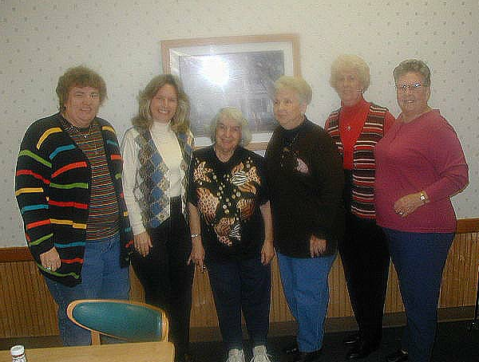
(L to R) Fran Novak, Peggy Allen, Isabella Tracy, Nan Barrow, Jenelle Berry and Pat Richardson

